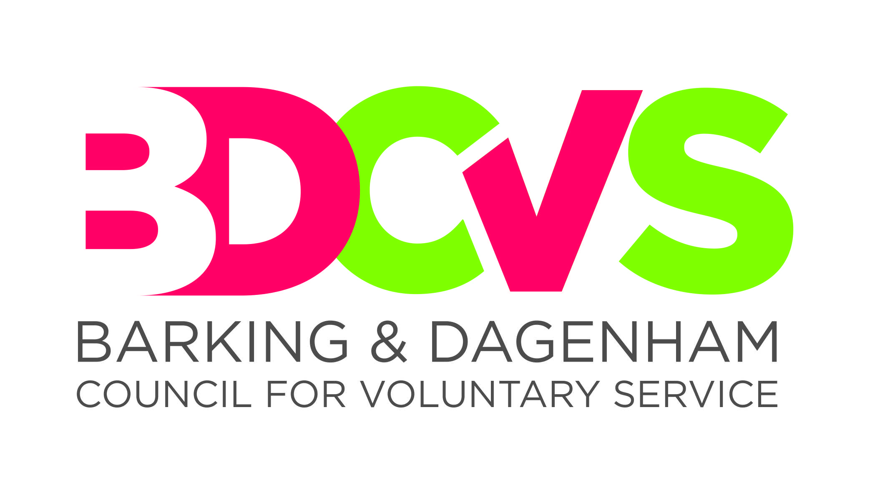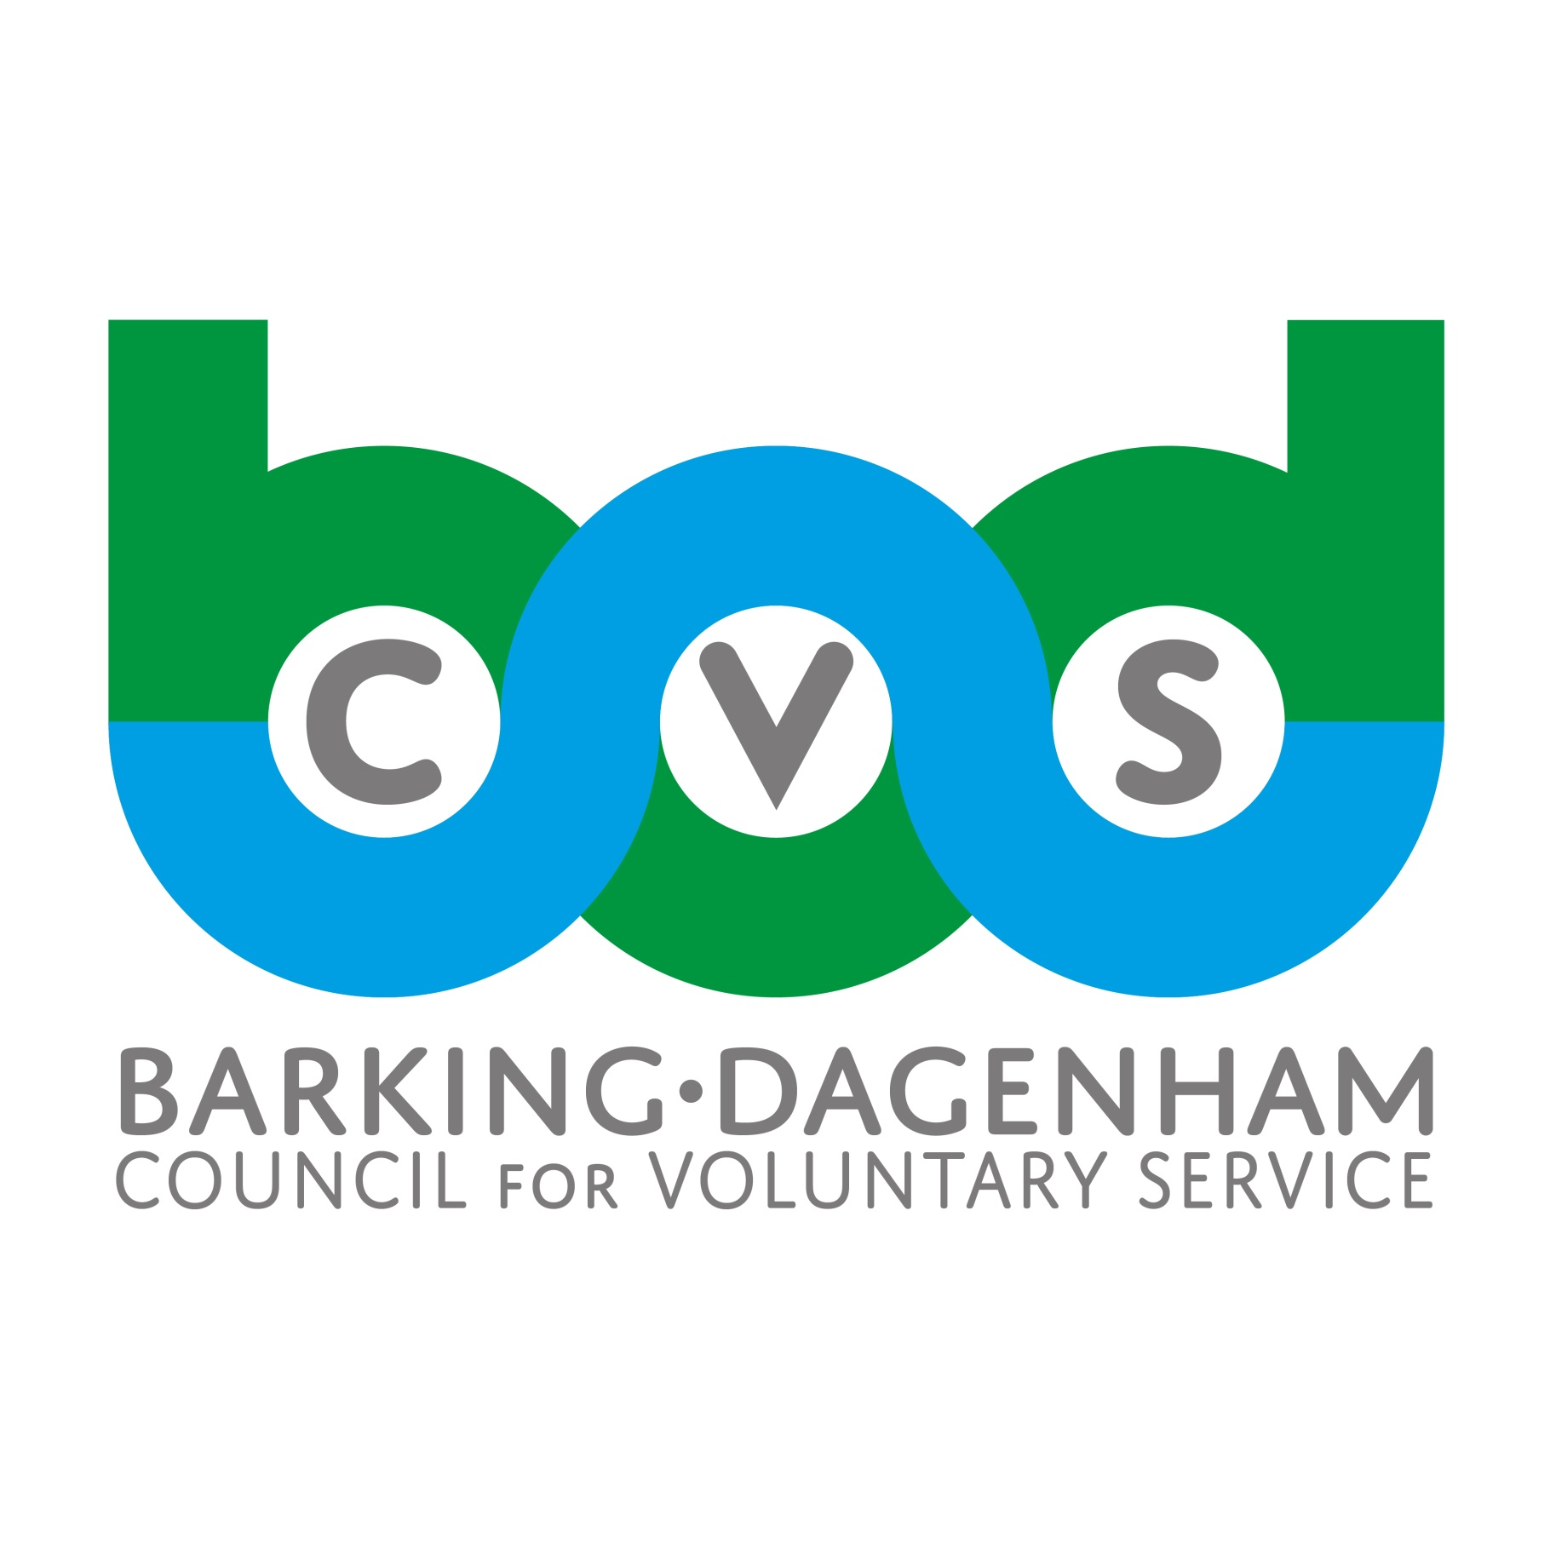

Barking & Dagenham Council for Voluntary Service

APPLICATION FOR
Chief Executive Officer

Please complete and return this form before the deadline of:Friday 10th April 2026

Late applications will not be considered

PERSONAL DETAILS

First Name:
Surname / Family Name:
Address:
 |  |  | Post Code:
Tel. (home): |  |  | Tel. (work):
Email:
May we contact you at work? Yes  No 

EDUCATION

Please tell us about your education and qualifications that you feel are relevant to this post. Include qualifications gained overseas and courses you are currently undertaking.

Subject | Level/Qualification and date gained | Institution where gained

TRAINING AND OTHER RELEVANT EXPERIENCE

Please give details of any training you have received or courses which did not lead to a qualification but which you feel are relevant to this post. This can include formal and informal, in-house and external training.

EMPLOYMENT HISTORY

Please give details of all your work history, starting with your most recent employment. Continue on a separate sheet if necessary, ensuring your name is clearly marked on additional sheets. Please include reasons for any breaks in employment.

1 | Current / most recent employer:
 | Address:
 | Job Title:
Duties and purpose of job:

Current/most recent salary:

Reason for leaving / intending to leave:

2 | Name of Employer/Organisation:
 | Address:
 | Job Title: |  |  |  |  |  |  |  |  | To:
 | Brief description of duties: |  |  |  |  |  | Salary:
 | Reason for leaving:

Please give details of relevant voluntary work or community activity you currently undertake or have undertaken:
Continue on a separate sheet if necessary, ensuring your name is clearly marked on additional sheets.

 | PERSONAL STATEMENT
 | Please provide relevant and specific examples to demonstrate how you meet the criteria set out in the Job Description and Person Specification. Invitation to interview for the post will depend on how well you meet these criteria.
 | Please do not provide more than 3 additional sheets for this section, and ensure that your name is clearly marked on additional sheets.

REHABILITATION OF OFFENDERS ACT

Under the provision of this Act you must give details of any unspent offences.

All successful applicants will be subject to a DBS Check.

The disclosure of convictions will not necessarily be a bar to employment and only relevant convictions will be taken into consideration at shortlisting or interview stage.

Have you any unspent criminal convictions or cautions? Yes No

Please give brief details if the answer is yes, eg. nature of offence, place and date of judgement, sentence.

REFERENCES

Please give name, address and telephone number of two people who can confirm your suitability for this position. One of these must be your present employer and the other a recent former employer. Relatives or partners are not acceptable as referees. All appointments are subject to the receipt of references satisfactory to Barking & Dagenham CVS.

First Referee |  |  | Second Referee
Name: |  |  | Name:
Position: |  |  | Position:
Organisation: |  |  | Organisation:
Address: |  |  | Address:
Telephone: |  |  | Telephone:
How is the referee known to you? |  |  | How is the referee known to you?
Please tick if you do not wish us to contact the referee before the interview |  |  | Please tick if you do not wish us to contact the referee before the interview
Where/how did you hear about this post?......................................................................................

Your answer will help us improve our future recruitment and marketing.

I certify that the information given on this form is correct to the best of my knowledge and I consent to Barking & Dagenham CVS checking any information provided. If a false or misleading statement is found, I understand that my employment may be terminated without notice.

Signed: ………………………………………………………………………….Date: ………………

All posts for Barking & Dagenham CVS require an understanding of the needs
of different communities in the borough. In addition, we require a strong personal
commitment to equal opportunities from all our staff.

Please return completed form to:
Sarah.robertson@bdcvs.org.uk

As a charity, Barking & Dagenham CVS has an obligation to keep its administrative costs as low as possible. It is therefore the organisation’s policy to only inform and provide feedback to candidates who are shortlisted for interview. If you have not heard from us within three weeks of the closing date, please assume that your application has not been successful on this occasion. Feedback will not be provided to candidates who are not shortlisted.

Charity No: 1012737
Company No: 2786597

