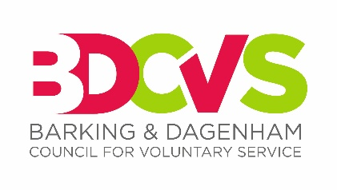
Advert for the position of
Chief Executive Officer

Salary: £30,600 per annum (pro rata £51,000 FTE) depending on experience.
3% Employer pension contributions
Hours: 21 hours per week (pro rata to full time 35 hours)
Duration: Start as soon as possible – 12 months
Location: Barking & Dagenham CVS, Ripple Centre, 121-125 Ripple Road, Barking, IG11 7FN
Introduction
We are looking for a new interim part-time Chief Executive Officer (21 hours per week for 12 months) to lead our infrastructure charity through the initial 12 months of a longer-term modernising change agenda.
Barking and Dagenham has been identified by London Funders as a ‘cold’ borough. Whilst the economic impact of the pandemic on VCSE, residents and communities has been large, Covid-19 has also unified a borough-wide civic renewal response. Building upon this together with other local infrastructure enablers is a priority. BDCVS has been a weakened infrastructure charity in recent years. A new trustee board is now landing a refreshed strategic plan in April/May and with it a 12-month business plan. The shorter-term outcomes of that Plan will drive the focus of this interim role.
We are looking for a social media savvy Chief Officer with successful experience of leading and managing change and a strong track record of fundraising and collaborative partnership building. You will have the energy and drive to seize major opportunities for the VCSE sector and for BDCVS within the current landscape. You will have a good understanding that outcomes are produced by whole systems rather than individuals, organisations or programmes.
Day to day you will lead a committed management team of 3 managers that cover Programmes, Operations and Business Development, ICT and communications. You will be supported by a motivated Board with an array of skills and led by an experienced Chair.
We would like you to start as soon as possible. There is flexibility as to days and times of work and for a blend of remote and physically office working.
Contact Chris Downham chris.downham@bdcvs.org.uk for an application pack or visit the jobs section of our website https://www.bdcvs.org.uk
The closing date for applications is Friday 10th April 2026. A shortlisting process will then take place and applicants will be invited to interview mid / late April.

